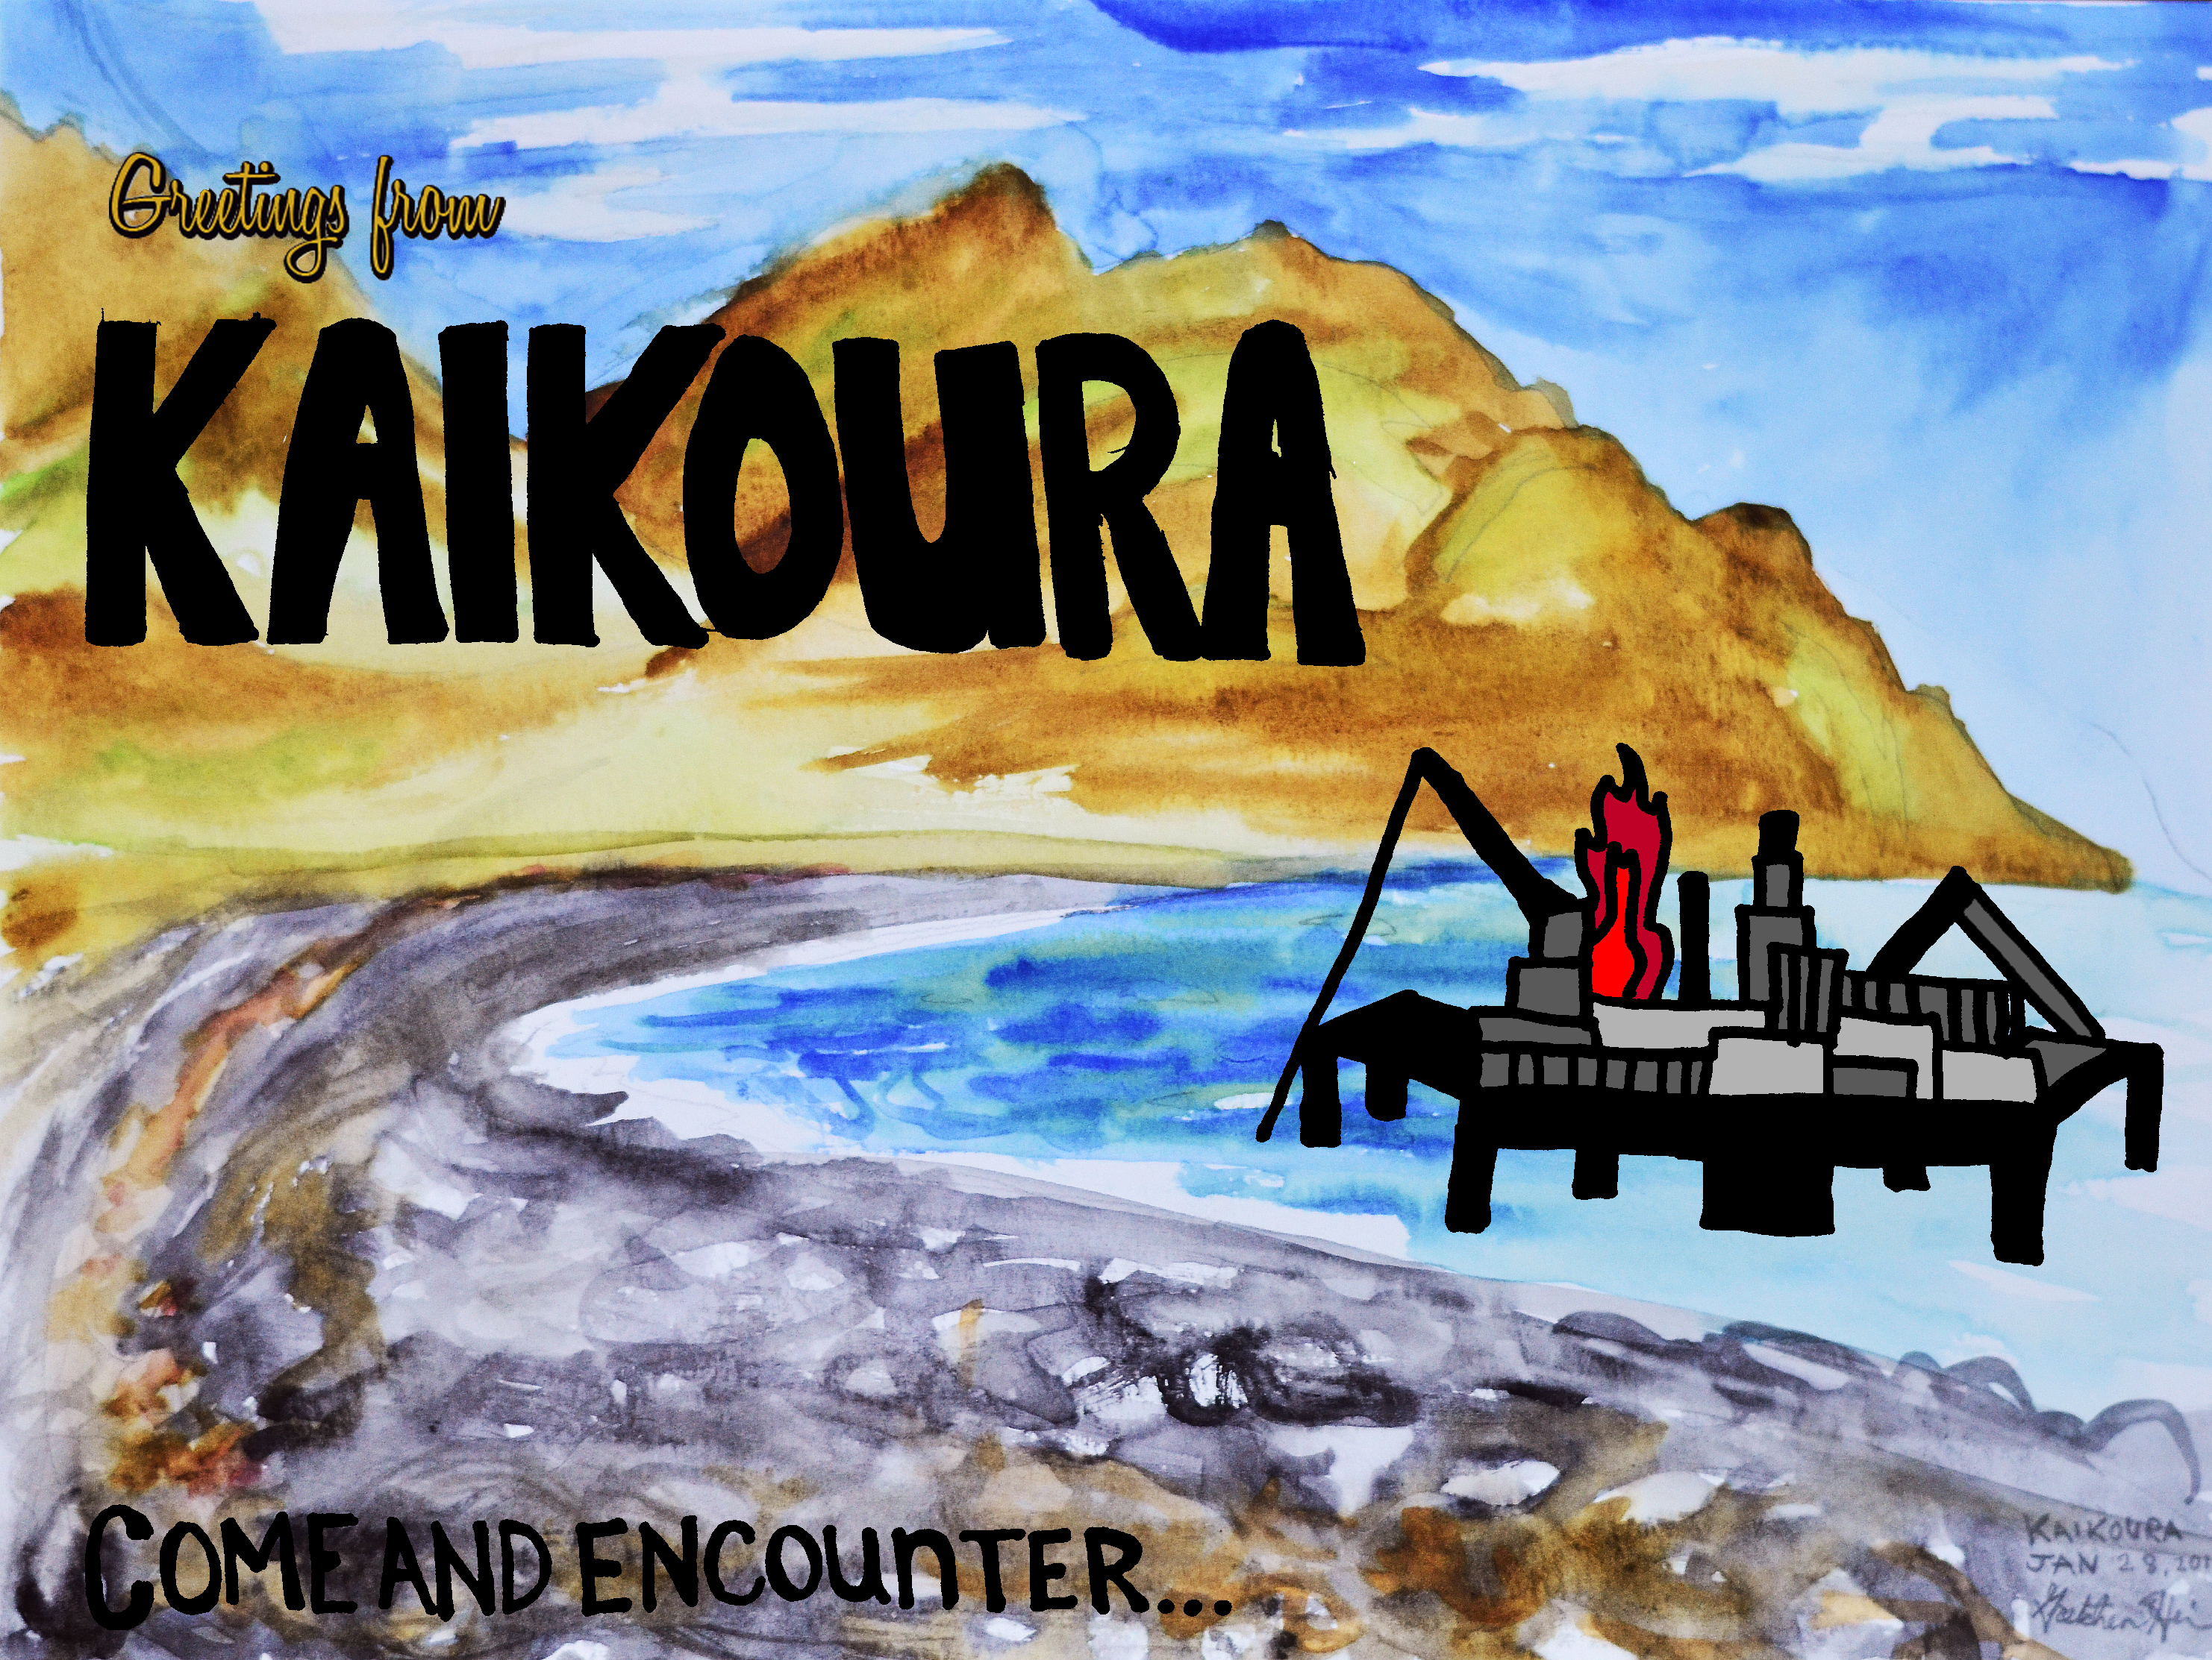

P R E S S K I T

Kaikoura Region Ecosystems and Communities:
Consequences of Carbon Exploration and Exploitation on Their Sustainability

Table of Contents

Postcard Watercolor……………………………………………………………………………………………………………. 1
Introduction………………………………………………………………………………………………………………………….4
Three Op Eds………………………………………………………………………………………………………………………..5
Nicole Mayberry……………………………………………………………………………………………………….5
Amanda Siegel………………………………………………………………………………………….……………….6
Tamara Lang…………………………………………………………………………………………………………….7
Letter to the Prince of Wales………………………………………………………………………………………………..8
News Articles……………………………………………………………………………………………………………………….9
Maps…………………………………………………………………………………………………………………………………..18
Costs and Benefits……………………………………………………………………………………………………………….22
Legal and Justice Issues - Amanda Siegel…………………………………………………………………………….24
Christianity Today Manuscript for submission – Tamara Lang…………………………………………….26
Conclusion………………………………………………………………………………………………………………………….30
Bibliography……………………………………………………………………………………………………………………….31

Editor’s Preface and Personal Note
My work as a professor at the University of Wisconsin-Madison is richly supported by the concept of “The Wisconsin Idea” that views the borders of the university as extending to the boundaries of the state, on to those of the nation, and out from that to the entirety of Earth’s biosphere. It is in keeping with this biospheric concept of teaching, research, and service that I accepted the opportunity to work with American students in New Zealand in the CCSP study abroad program to address environmental stewardship in biospheric perspective. My students in New Zealand were introduced to the “Science-Ethics-Praxis Triad” that I use in framing of science, ethics, and praxis in developing and applying solutions to environmental issues and problems—all directed toward maintaining a habitable Earth. This triad is built upon three questions: (1) how does the world work? (Science, Scientia); (2) what ought to be? (Ethics); and (3) then what must we do? (Praxis). It is more fully described—in the context of the biospheric economy at: http://nelson.wisc.edu/people/dewitt/docs/earths_biospheric_economy.pdf

Scientia
 How does the world work?

Ethics Praxis
What ought to be? Then what must we do?
Following their work with me on this triad, I met individually with all 19 students to review their reflective journal and course notes, and to ask them how they expected us to conclude our time together. All of them said they expected to conclude with the production of a substantial and significant answer to the third question, “What must we do?” This press kit is a result of our answering that question together at the place of our study: Kaikoura, New Zealand, and the Kaikoura undersea Canyon whose depth reaches 1000 meters just off shore and whose abundance of giant squids and other marine life support Sperm Whales and another 13 species of related cetaceans. Together we hope that this helps foster and nourish a vital stewardship whose dimensions extend from the Kaikoura Coast and Canyon on to the whole of the biosphere.
Authors
Jessica Adams, Gentry Bain, Kameron Bechler, Bethany Bender, Rick Buteyn, Tor Ekstrom, Noah Fields, Gretchen Heim, Elizabeth Knepper, Caleb Kragt, Tamara Lang, Nicole Mayberry, Dana Miller, Olivia Norman, Karina Scavo, Amanda Siegel, Alexandra Steele, Ashley Walker, Elise Wetherell

Editor and Acknowledgements
Calvin B. DeWitt - Professor, University of Wisconsin-Madison and member of the graduate faculty of Conservation and Sustainable Development, Water Resources Management, Environment and Resources, and Limnology and Marine Science and Editor of this Pres Kit report. Phone: 001-608-2221139 Email: cbdewitt@wisc.edu
Caleb King - Teaching Assistant, Creation Care Study Program (CCSP), Kaikoura, New Zealand, and Assistant to the Editor of this Press Kit report.
John Geating - Staff, CCSP, Kaikoura, New Zealand
Jess Miller - Staff, CCSP, Kaikoura, New Zealand
Alicia Landis – Program Administrator, CCSP, Kaikoura, New Zealand
Courtnay Wilson, Program Director, CCSP, Kaikoura, New Zealand

Introduction
We, university students of Calvin B. DeWitt at Kaikoura, New Zealand with the Creation Care Study Program,* have compiled this packet to make known the threat that offshore petroleum exploration present to the people of Kaikoura, the ecosystems of Kaikoura Canyon, and the beauty and integrity of Aotearoa New Zealand in general. Two of the many blocks that will be open to bidding from oil companies on April 27, 2012 are located on the Hikurangi Trench, the larger ocean system that reaches the nearest to land just south of the Kaikoura Peninsula and makes possible its unique biodiversity. This is cause for alarm because seismographic mapping and oil drilling are all contrary to basic New Zealand values: The risk of massive ecological harm and certainty of overall negative environmental impact far outweigh the economic benefit.
If offshore drilling is conducted, the best-case scenario would begin with a relatively clean extraction of petroleum. This would have only minor direct impact on the environment-perhaps-but as these fuels are burned, the unavoidable effects are released. Through exporting fossil fuels, there will be contributions to the rapidly increasing carbon dioxide levels known to cause global climate degradation, thanks to parliament’s policies. While the rest of us supporting a green, “100% Pure” New Zealand look on, these decisions will undermine the sustainable industry in ecotourism for an entirely unsustainable industry. Ecotourism could continue indefinitely if New Zealand’s purity is maintained, but the oil industry in its very nature has a limited life.
Then again, if the process does not sail as smoothly as advertised, consequences could be suddenly and terribly realized. One earthquake can change everything (as Kiwis know all too well today), and nobody knows the result of drilling at the meeting of the Australian and Pacific plates. The depth in the proposed blocks far exceeds the depths and pressure that proved unmanageable in the Gulf of Mexico (in which the area impacted covered 180,000 km², while the South Island covers a little more than 150,000 km²). The Ministry of Economic Development cannot claim to have answers for what will happen when an earthquake impacts the drilling operations.
Either outcome—catastrophe or best-case scenario—is unacceptable.
New Zealand depends on and is proud of its ecotourism. Kaikoura’s wellbeing revolves around it. New Zealand recognizes past mistakes in the human-caused extinctions of numerous species, and now seeks to protect its priceless endemic life. Kaikoura began its life as a whale-slaughtering station, but has found new life with marine mammal encounters and ecotourism. New Zealand has cultivated an attitude of care toward the Earth; Kaikoura’s life depends on upholding such commitment.
Perhaps that will help readers understand why these materials are compiled from the perspective of Kaikoura, although there will be blocks far away and although others may technically be closer to 12PEG1 and 12PEG2 than Kaikoura. If alarm is dismissed as “only local” anywhere, the sum of local voices will be dismissed more easily everywhere. We hope that these materials may assist your action in this crisis.
* Creation Care Study Program is a non-profit tertiary education program for North American students to study abroad in Kaikoura, New Zealand, with a sister program in Belize. Its primary focus is on environmental studies and sustainability issues—caring for people, places, and the planet.

100% Pure New Zealand?

As an American student currently studying in Kaikoura through the Creation Care Study Program, I share your concern regarding the atrocity that is taking place in New Zealand right now – specifically in Kaikoura. New Zealand Petroleum and Minerals, a branch of the Ministry of Economic Development, is attempting to allow for oil drilling off the shores of Kaikoura. This is a high threat as Kaikoura is located adjacent to the Hikurangi Trench and the Australian and New Zealand fault lines, in earthquake prone area. Kaikoura has an extensive and astounding coastal and marine environment because of the Kaikoura Canyon. Creatures like the sperm whale, dusky dolphin, and fur seal who call the Kaikoura waters home would be dramatically impacted by petroleum exploration and exploitation. What would Kaikoura be without its remarkable sea life? What would the mention of Kaikoura be without “have you seen the whales?”
Parliamentary environment commissioner Dr. Jan Wright is looking into the effects of this proposal and is supposed to be consulting “affected parties”. However, main representatives of Kaikoura have yet to be sufficiently consulted. These groups include the Kaikoura branch of Forest & Bird, Whale Watch Kaikoura, Encounter Kaikoura, Kaikoura Information Tourism Incorporated (KITI), coastal marine guardian group Te Korowai o Te Tai o Marokura. and the Kaikoura District Council. Also, if the drilling operations were to destroy the marine life, this would destroy the ecotourism on which Kaikoura vitally depends. If New Zealand Petroleum and Minerals is not consulting those immediately affected by the exploration, how will the company truly be able to know the best means of protecting the environment here? How will the company know which technology to use? As it is, Dr. Jan Wright was quoted as resolving that New Zealand does not even need to resort to oil exploration, because of the other – and greener! – energy alternatives.
New Zealand does not need to resort to oil exploration and exploitation, especially in light of the massive negative affects that are probable. As a citizen of this beautiful world, and a visitor to this beautiful country, I find myself remembering that I am dependent on this world. If all I do is rape and degrade it for all its worth, what will be left?
New Zealand prides itself on being “100% Pure,” but how pure will New Zealand be if we just let this happen? Please protest the petroleum exploration that is about to occur in New Zealand. Keep New Zealand “100% Pure.”

Sincerely,
Nicole Mayberry
Jacksonville, NC

Amanda Siegel Op-Ed

I am a student, an American, not a Kiwi. But I have been given the privilege to live and study in this beautiful country for a short time. As I’ve traveled, I’ve become accustomed to introducing myself, talking about my classes, California (my home state), and Kaikoura, the town I temporarily am able to call home. There is, without fail, one question I will always encounter when Kaikoura enters the conversation: “Have you seen the whales?” I love this question. Perhaps to a Kaikoura local it grows tiresome, but, being an overenthusiastic foreigner, I smile and gush because yes, I have seen the whales! I’ve studied them in fact, the impossible dives of the sperm whales, the feeding of humpbacks, the size of blue whales, and the play of dusky dolphins. They’re magnificent. To see them in person has left a mark of wonder on me that I hope I’ll never forget. You truly have a gift in Kaikoura. Whales at your doorstep.
I don’t think I’m the first to let you know but I may be among the last to express this joy. The proposal to drive drills into areas immediately upstream from the canyon, in heavily faulted earthquake prone territory could effectively put an end to the question “Have you seen the whales?” History tells us the potential for oil spill, mass habitat destruction, and disappearance of once abundant species is more of a likelihood than a risk. Not to mention the severe potential seismic destruction could wreak, joining the tragedy that so recently befell the city of Christchurch
Allow me, a mere outsider, to urge you who call this precious place home to action. Do not allow this to happen. You have here a resource far more valuable than a small cut of an oil profit, and much more enduring. Generations will desire to experience it, the vastness and wildness that can render us gloriously diminutive in its face. Nothing like the Kaikoura canyon exists anywhere else in the world, though graveyard disaster sites of drilling are all too common. It’s a story far too predictable and tragic. This is your canyon, your treasure, don’t give it away to be raped and plundered in silence. Be outraged, be loud, and be stubborn! I can only ask this as a favor. This is your place, you have shared it with me and I’ve fallen in love with it. It’s unthinkable that I should return so many years in the future and find it dead and barren. Unthinkable, but not impossible. I write this to join with those who won’t let this decision occur in silence and to ask you to do the same.

-Amanda Siegel

Painting the Ocean Red: A Response to Kaikoura Oil Exploration

Mere decades ago, you couldn’t walk around the Kaikoura peninsula without wading through the blood of whales. Your feet would have been stained by the lifeblood that had once passed through a heart larger than yourself, but which now dyed the rocks and tide pools a mocking red.
Why were these giants of the sea reduced to pulp? The answer is the same word that today reverberates throughout Kaikoura: oil.
At this very moment, New Zealand Petroleum and Minerals is seeking to begin oil drilling off of the Kaikoura coast. The place where they seek to drill is a trench adjacent to the Kaikoura canyon, a 2500- meter deep undersea chasm that fosters a vibrant array of deep-sea life. This canyon serves as the food basket for a host of marine mammals, including 14 species of whales and dolphins that thrive in the rich productivity of these waters. Kaikoura boasts a diversity of marine life that is unique on the planet; fur seals, sperm whales, dusky dolphins, and albatrosses can all be seen in the space of a single morning.
As an American citizen, I can remember when our own Gulf Coast hosted a similarly robust marine life. Many coastal towns, like Kaikoura, were hot-spots for ﬁshing and tourism. Entire communities thrived on the richness of their ocean.
Then, in the space of a single morning, on a single oil rig, a single accident obliterated this richness.
Weʼve all seen pictures of marine animals after oil spills -- feathers pleated with oozing gunk, corpses of seals pushed through black waves onto a black beach. Imagine a mollymawk, or a royal albatross, suffering this foul fate. Imagine a sperm whale surfacing in a sea as dark as his own skin.
If oil drilling is allowed in Kaikoura, it is only a matter of time before this horror becomes a reality. 2500 meters of pipeline, reaching from a volatile bottom to a wild surface, will be strung in a region of precarious seismic stability. Think of Japanʼs nuclear meltdown following an unforeseen quake. By placing oil drills in the canyon, we are condemning Kaikouraʼs marine life to a similar fate.
Perhaps it may be a decade, a century, a few centuries before a quake hits
Kaikoura. However, by placing this equipment in the ground, we are creating a time bomb that we know little about. It may be that our great-great grandchildren will have to see the destruction of the Kaikoura canyon, or perhaps we ourselves will be forced to deal with our own foolishness.
In the face of this danger, a question arises: is this gamble really worth sustaining an industry that will take much of the proﬁt overseas?
In the past we have dyed the rocks red with our greed; let us not now paint them black with our folly. We owe it to the rocks. We owe it to the birds. We owe it to the whales.
And, insofar as we are a part of this world, we owe it to ourselves.

- Tamara Lang

Your Majesty, Prince of Wales,

Kia ora from Kaikoura, New Zealand! I am an American student studying in Kaikoura, New Zealand at the Creation Care Study Program. Its purpose is to educate university students like me about the importance of the protecting the environment for the preservation of the future. Studying under many intelligent and wonderful professors, I have become more aware of the need to conserve, preserve and restore the environment. Thus, when it was brought to my attention that the New Zealand government, that uses the slogan, “100% Pure New Zealand,” had decided to section off and sell blocks of ocean for oil and gas exploration, I felt compelled to become more informed and involved.
Your Majesty, I have heard so much of your great heart for those less fortunate and your heart for nature. I was greatly excited to hear about your work with the Hampshire Fare with the Countryside Fund, and your dedication to your gardens. Sir, I sincerely applaud your patronage to the National Council for the Conservation of Plants and Gardens (NCCPG), and as a fellow conserver of nature and environment, I plead with you to please also grace Kaikoura with your attention to this development.
New Zealand is located right over the Australian and Pacific tectonic plates, creating the most biologically rich ocean habitat known in the world called the Kaikoura Canyon, that is home to many marine mammals, including the sperm wale – which Kaikoura is renown for – fur seals and dusky dolphins. Sir, as you have yourself seen the beauty of Kaikoura when you visited a few years ago, you would understand the need to protect this beautiful place and its beautiful seas. However, New Zealand Petroleum and Minerals has designated two of the offshore blocks closest to Kaikoura (12PEG1 and 12PEG2, of which 12PEG1 is seventy-five kilometers from the Kaikoura peninsula) directly over the Hikurangi Trench and Hope fault line, directly on the front steps of this wonderful diversity of marine life.
Recently, a number of residents of Kaikoura organized a protest here to raise awareness of the petroleum exploration that has been proposed, and its potential for damaging this fragile environment. As you undoubtedly know, this process has the potential to allow many chemicals to contaminate the water, to raise the risk of oil spills. Sir, all of these consequences would have disastrous effects. Also, Your Majesty, if the marine life disappears in Kaikoura, so does the economy of Kaikoura, which depends on ecotourism. The local community is almost entirely dependent on the sea for its livelihood. With your support and influence, Kaikoura continue to survive and thrive along with he wonderful richness and diversity of the sea.
Letters have been written by the Kaikoura branch of Forest & Bird, Whale Watch Kaikoura, Encounter Kaikoura, Kaikoura Information Tourism Incorporated (KITI) and coastal marine guardian group Te Korowai o Te Tai o Marokura, which all explained the special values of the Kaikoura coast and the marine environment. However, the Minister of Energy and Resources, Phil Heatley, has denied the call for a moratorium on the activity. The residents of Kaikoura and the staff and students of the Creation Care Study Program believe this to be a grave mistake.
Sir, as a fellow conserver, preserver, and restorer of nature, I plead with you to utilize your authority to stop the petroleum exploration in New Zealand. If the exploration does occur, I worry that Kaikoura may not be the same beautiful and thriving town twenty years from now. I dearly wish to come back to Kaikoura someday with my children and pass on my love and service to nature to them, which would not be possible if the marine life of New Zealand is destroyed by the petroleum exploration, and God forbid, oil spills.
I dearly hope you consider my pleas, and the pleas of the citizens of Kaikoura and even from citizens of the deep - from the baby fur seals to the sperm whales, from the wandering albatrosses to the bull kelp. A Cree Indian prophesy states that “Only after the last tree has been cut down, only after the last river has been poisoned, only after the last fish has been caught, only then will you find that money can not be eaten.” Sir, I do not want us to reach that point, so we dearly need your help. Thank you for your consideration.

Yours sincerely,

Nicole Mayberry

News Articles

This section details the response of local and national media in regard to proposed off shore drilling. The public reaction has been highly negative, resulting in local protests and petitions. Very little international attention has been given to this issue; however, the Marlborough Express, the Kaikoura Star, and the New Zealand Herald have closely followed the controversy and have provided the following articles and information.

The Marlborough Express:
Seismic tests given the go-ahead
JARED NICOLL

Last updated 16:00 28/12/2011

http://www.stuff.co.nz/marlborough-express/news/kaikoura/6194457/Seismic-tests-given-the-go-ahead

The Government will offer oil and gas exploration companies the opportunity to conduct further seismic tests off the Kaikoura coast despite a lack of research on its effect on marine life.
The Economic Development Ministry's Petroleum and Minerals department will open up specified ocean spaces around New Zealand to bids from oil and gas exploration companies in the first quarter of next year. Some of the areas may include Pegasus Bay, which lies between North Canterbury and the Wairarapa and extends for several hundred kilometres towards the Chatham Islands.
Initial work for oil and gas exploration included seismic testing, but studies on the effect of the testing on marine life remain largely observational and further research is years away from completion.
Seismic testing conducted in the same area in 2009 involved firing powerful airguns into the ocean at timed intervals. This created low-frequency pulses which echoed back off the ocean floor.
The pulses were recorded and used to create two-dimensional images of the geological makeup of the area. The images were used to help determine the likelihood of gas or oil reserves below the surface, but these can't be confirmed until the area is drilled.
Canterbury University Edward Percival field station marine biologist Manuel Fernandes specialises in sperm whale foraging based on acoustics research, and previously worked as a marine observer on board seismic testing vessels. He said boats emitted low sound frequency pulses that ranged from 200 to 300 hertz.
Whales could hear the sound from potentially thousands of kilometres away, but how it affected them remained unknown. The only available research was on the direct effects the boats had on the whales, which involved monitoring their movements in regard to the vessel, but not enough was known about their intentions and routines to draw any conclusions.
Studies needed to be conducted on the indirect effects, such as whether the pulses masked the whales' ability to listen for food or communicate with other whales.
"First, we have to be sure there is an effect, but we don't really know," Mr Fernandes said.
"The whales are more likely to be affected than dolphins, due to the whales' low vocalisation frequencies."
A misconception was that seismic testing vessels caused whales to become stranded or rush to the surface too quickly to survive.
This effect was commonly caused by the stronger and higher frequency sonar pulses used by navy vessels.
"There is a very strong correlation and it's very close to being scientifically proven," Mr Fernandes said.

Ministry of Economic Development chief petroleum geologist Richard Cook said the ministry would award an exploration permit to a company based on its planned work programme for the area.
Permits for "blocks" of ocean space off the Kaikoura coast would be opened for bidding in the first quarter of next year, he said.
Explorers would conduct detailed three-dimensional tests on specific areas of interest taken from the broader two-dimensional image tests.
The company would be given five years to conduct its tests and, if successful, would be likely to drill in the area, he said.
Seismic testing vessels had to stop their tests if a whale was spotted within one kilometre of the boat.
"We discussed the testing with Whale Watch [in 2009], and put a 10-kilometre exclusion zone around their activities."
Central government earned about 45 per cent of the profit from a successful exploration company's oil or gas trade, he said.
Te Korowai o Te Tai o Marokura chairman John Nicholls said the coastline protection organisation would seek to negotiate with any exploration company that wanted to conduct seismic testing in Kaikoura.
"[Dr Cook] was at our strategy launch but currently we are looking to work with all those organisations to ensure we don't have any issues arising from it," Mr Nicholls said.
"One would hope that the government would listen to [us] if we can show genuine issues.
"We have strong support from the government for what we are trying to accomplish but they have to look at the big picture – nothing's ever given but if you don't try, you're going to fail anyway."
Green Party MP Steffan Browning said the testing was of concern due to the lack of available research and, if successful, could lead to intensive drilling techniques such as fracking.
"Why bother exploring for something that you wouldn't want to extract anyway," he said.

The Kaikoura Star:
Oil protest petition gathers support
EMMA DANGERFIELD

Last updated 07:24 23/03/2012

http://www.stuff.co.nz/marlborough-express/news/6624346/Oil-protest-petition-gathers-support

Organisers of a protest over possible offshore drilling near Kaikoura hope to have more than 1000 signatures on a petition to be presented to MPs on Sunday.
More than 800 names have been collected so far.
A protest against offshore drilling is being held in Kaikoura on Sunday at the town's peninsular lookout on Scarborough St.
Concern has been mounting over the tender of offshore blocks for oil and gas exploration, which could include seismic mapping, drilling and fracking.
Twenty-five offshore blocks were released by Energy and Resources Minister Phil Heatley on February 9.
The petition calls for the withdrawal of the two offshore blocks closest to the district, about 50 kilometres to the northeast.
The petition also calls for for the offshore portion of a permit in a third block, from Kekerengu to Marlborough Sounds, to be declined. Those behind the petition believe the risks of deep-sea oil exploration are unacceptable.
One of the driving forces, Lynda Kitchingham of Kaikoura, said copies had been spread far and wide in the hope of attracting as many names as possible.
While it was difficult for her to determine exact numbers before the petition was collected at the end of the week, she was aware of copies circulating as far away as Christchurch and Dunedin.
Many businesses around town, including prominent marine-based tours such as Encounter Kaikoura and Whale Watch, as well as shops, cafes and bars, were also collecting signatures, she said.
Green MPs Gareth Hughes and Steffan Browning will be at the event on Sunday at the Kaikoura lookout to receive the petition, although Ms Kitchingham said the collection of signatures would continue throughout the following week, with the final tally being given to Parliament on April 1.
Kaikoura MP Colin King declined an invitation to attend because of another commitment.
Speakers at the protest will include Te Runanga o Kaikoura representative Maurice Manawatu and Ralph Hogan, who was instrumental in bringing the Marlborough District Council's and the community's attention to the prospect of offshore drilling.
The Kaikoura District Council has written to New Zealand Petroleum and Minerals general manager David Binnie, outlining concerns on behalf of the community regarding the offshore blocks closest to Kaikoura, 12PEG1 and 12PEG2, as well as the offshore section of permit 52676.
The letter, signed by Mayor Winston Gray, raises several concerns including the risk of an oil spill and the capacity of New Zealand authorities to deal with it, the effect of seismic activity on marine mammals, and the dependence of the local community on marine life and fishing.

Three of the offshore blocks lie directly over the Hikurangi Trench and Hope fault line.
The council has asked for a moratorium on fracking, where high-pressure fluids are injected into a rock formation.

The Kaikoura Star:

'No drill' protest on Sunday
EMMA DANGERFIELD

Last updated 09:46 23/03/2012

http://www.stuff.co.nz/marlborough-express/news/kaikoura/6613328/No-drill-protest-on-Sunday

A number of local groups and organisations have joined the council and written to the government voicing their concerns about the risks associated with oil and gas exploration off the Kaikoura coast.
The Kaikoura District Council has sent a letter to New Zealand Petroleum and Minerals general manager David Binnie, outlining concerns on behalf of the community regarding the off-shore blocks closest to Kaikoura, 12PEG1 and 12PEG2, as well as the offshore section of permit 52676.
The letter, signed by mayor Winston Gray, raises a number of concerns including the risk of an oil spill and the capacity of New Zealand authorities to deal with it, the effect of seismic activity on marine mammals, and the dependence of the local community on marine life and fishing.
Similar letters have also been written by the Kaikoura branch of Forest & Bird, Whale Watch Kaikoura, Encounter Kaikoura, Kaikoura Information Tourism Incorporated (KITI) and coastal marine guardian group Te Korowai o Te Tai o Marokura.
In a detailed four-page letter, Te Korowai sets out to explain the special values of the Kaikoura coast and marine environment. The letter outlines cultural concerns and explains the significance of the Hikurangi Trench to the people of Ngati Kuri. Three of the off-shore blocks in question lie directly over the Hikurangi Trench and Hope fault line.
The letter also explains that the Kaikoura Canyon is home to the most biologically rich ocean habitat known in the world at depths of below 500m. It is 100 times richer than the next documented area at this depth outside areas with the life-support system of hydrothermal vents.
Te Korowai's letter goes on to list a number of marine mammals which use these waters and which they consider to be sensitive to petroleum exploration, including the sperm whale for which Kaikoura is world-renowned, fur seals and a variety of dolphins.
Economic impact of a large-scale disaster is also mentioned in the letter:
It appears, however, that local concern and knowledge is falling on deaf ears as only those legislative bodies deemed affected parties are being consulted. The ministry has produced a list of iwi and councils with whom it will consult, and is not taking public submissions from any other parties, including those listed above.
Minister of Energy and Resources, Phil Heatley, told the council in a separate letter that a new bill to manage environmental effects was before parliament which would cover blocks more than 12 nautical miles from the coast. Organisers are asking that any uncollected petitions be dropped off at Detail, West End, this Friday.
Lynda Kitchingham says concerned residents are being asked to make a stand by spreading the word and meeting at the Scarborough St lookout at 4pm this Sunday.
There will be music, guest speakers and the petition will then be handed over to MPs.

The Kaikoura Star:
Kaikoura takes fracking action
EMMA DANGERFIELD
Last updated 12:49 08/03/2012
http://www.stuff.co.nz/marlborough-express/news/kaikoura/6543275/Kaikoura-takes-fracking-action
Concern is mounting in Kaikoura over the tender of offshore blocks for oil and gas exploration, which could include seismic mapping, drilling and fracking.
Twenty-five offshore blocks were released by Energy and Resources Minister Phil Heatley on February 9.
A petition is being circulated around Kaikoura calling for the withdrawal of the two offshore blocks closest to the district (about 50 kilometres to the northeast).
The petition is also calling for the offshore portion of a permit in a third block, from Kekerengu to Marlborough Sounds, to be declined. Those behind the petition believe the risks of deep-sea oil exploration are unacceptable.
Kaikoura resident Lynda Kitchingham said she was forced to act after considering the widespread environmental damage caused by oil spills around the world.
"When you take into account the depth of water in these blocks, which is in some parts 2500 metres, compared with the Gulf of Mexico Horizon spill at 1500m, the movement of currents and the underlying geological instability, deep-water drilling in these blocks could be an ecological timebomb for the Kaikoura marine environment," she said.
"The size of the area wiped out for fishing following the Gulf spill is roughly the size of the South Island. Local fisherfolk should be very concerned."
Ms Kitchingham said one of the most significant recommendations in the Te Korowai o Te Tai o Marokura draft strategy was the application for World Heritage Status. Te Korowai is the coastal guardians organisation in Kaikoura.
The granting of this status would enhance Kaikoura's reputation as an international eco-destination, and so to even contemplate upcurrent deep-water oil drilling around that area beggared belief, she said.
An event is being organised to give the Kaikoura community the opportunity to show its opposition to the tender, on March 25 at 4pm at the lookout on Scarborough St, and to officially hand the petition to members of Parliament.

The Kaikoura Star:
Fracking no good for eco-tourism
EMMA DANGERFIELD
Last updated 15:37 15/02/2012
http://www.stuff.co.nz/marlborough-express/news/kaikoura/6420034/Fracking-no-good-for-eco-tourism
One year ago, had you asked anyone what fracking was, the likelihood is that they couldn't tell you. But the controversial topic is becoming more present on social networking sites and amongst communities around New Zealand, and one local in particular is keen to bring it to the attention on a local level.
Ralph Hogan, who moved to Kaikoura in part because of its environmental principles and efforts with minimising waste, says the Kaikoura District Council and the community need to make a stand with immediate effect before a whole raft of issues presents itself, potentially compromising Kaikoura's integrity.
Mr Hogan, who approached council at its meeting in December last year to discuss fracking, tabled the subject again on the Tourism and Development committee's agenda last week. Fracking is the injection of fluid into rock to recover fossil fuels.
Mr Hogan asked committee members to support a recommendation to council that a moratorium on fracking be sought from central government until more information on the practice can be researched.
The request comes after Christchurch City Council wrote a letter to minister of energy and resources Phil Heatley asking for the same.
Mr Hogan went one step further than the request from Christchurch, and said Kaikoura should insist all fracking resource consent applications be publicly notified. Currently the RMA states that only the adjacent neighbour need be informed.
Mr Hogan said public notification was essential, not only for anyone concerned about the quality of groundwater but also because there could be specific expertise within a community which could be of benefit.
His third concern was that offshore blocks were about to start being sold and Kaikoura waters would not be immune to this. This had the potential to undermine efforts made by coastal guardian group Te Korowai O Te Tai O Marokura, who were in the midst of finalising a strategy for the protection of the area, including marine reserves. Not to mention any adverse effects on marine life, as yet unknown.
"Both from the standpoint of real and perceived views, it would be very detrimental to the narrow field we have here," he said.
"We are pretty tied to tourism, eco-tourism in particular."
Regardless of how successful council's efforts turned out to be, it was important for Kaikoura to speak up and stand by its Green Globe/Earth Check policies, he said.
Tourism operators around the table agreed, saying the argument needed to be focused on the unique qualities of Kaikoura. Encounter Kaikoura owner Lynette Buurman said something had to be done.
"It's not just about marine mammals, it's our ocean, fisheries and environment... we have to stand together and be cautious about this."
Whale Watch Kaikoura chief operating officer Kauahi Ngapora said it was also extremely important for the committee and the wider council to start making noise and reminding others what Te Korowai was working towards.
"From my perspective it's black and white... we don't want any forms of oil or gas exploration whatsoever."
In a statement released last week energy and resources minister Phil Heatley has welcomed the latest block offer process for awarding gas and oil exploration permits in selected areas. The 2012 proposed block offer covers 25 areas, a move labelled by Mr Heatley as "an important step in developing New Zealand's significant resource wealth".

The New Zealand Herald:
Troubled waters over oil
KIM KNIGHT
Last updated 05:00 29/05/2011
http://www.stuff.co.nz/national/5069775/Troubled-waters-over-oil
Greenpeace is predicting more angry protests as the public wakes up to the amount of oil exploration planned in coming years.
This year there have been significant protests against Petrobras exploring in the Raukumara Basin, and last week opposition increased against Australian mining company Greywolf NL's plans to explore the seabed for oil offshore of the Abel Tasman National Park.
This week, the Star-Times investigates the state of oil exploration in New Zealand and discovered a country pockmarked with petroleum exploration permits – and brand new applications over some of our most pristine and tourism-dependent environments.
Punakaiki. Te Anau. Kaikoura. They're all in, or near, the areas covered by the 10 new permit applications received this year - three in the past fortnight alone.
And famous beaches, including Piha and Ninety Mile beach, adjoin the area of ocean where the government has offered up two "block offers" to prospectors.
Bids closed in August, but neither the bidders nor winners have been revealed. Hekia Parata, acting energy and resources minister, said "there has been some very substantial assessment going on".
Greenpeace campaigner Simon Boxer told the Star-Times: "I think the rest of the world looks at us and wonders what the hell we are playing at."
He predicts local opposition will increase "when a good third of the population is going to see this right off their coast".
In 2006, 18 petroleum exploration permits were granted; in 2007, there were 21; 15 in 2008 and 11 in each of the past two years.
In total, there are 70 granted petroleum exploration permits, and 23 more applications pending.
WHAT LIES BENEATH
A briefing paper released by Greenpeace a week ago, cites Investment New Zealand research showing 250 local organisations involved in researching, developing and commercialising "clean" technologies. It's believed 60 of these companies are potentially world class – and there is potential to create a $150 billion high-value low-carbon export economy by 2025.
"The big fear is this isn't a window that is going to be open for that long, and there are many competitors out there who are starting to win big contracts," says Boxer.
"Here's this massive opportunity to shift the economy for a long-term leadership role and they just can't seem to see it."
CAN WE have our cake and eat it too? Boxer says spending money on fossil fuels strips jobs and economic growth from the cleantech sector.
"It's not an either/or situation," argues Parata. "It's an and/and approach... renewables are a significant part of our portfolio."
She says government is "dedicated to working towards a low carbon future, but the fact is fossil fuels are going to be part of the world's future as we transition".
Last year's study by Venture Taranaki found the oil and gas industry directly employed the equivalent of 3730 people and, in 2009, contributed $1.9b to the New Zealand economy.
"Taranaki has been our longstanding domestic experience of this industry," says Parata. "We know from the seismic mapping that's been invested in by previous governments, including ours, that there's a larger mineral and gas resource out there and need to have the capacity and capability to properly assess how that potential might be realised."
Parata says in the exploration phase, like that recently initiated in the Raukumara Basin by Brazilian company Petrobras, little money is earned, "other than the fees paid for permits". (Companies interested in the Northland and Reinga offers, for example, were required to pay an initial fee of $6000 per contested block.)
"Companies are bearing the cost of the research," says Parata, "so in that stage of the process, there is little direct revenue."
She says people should understand it's an industry that works on "very long time lines".
Petrobras's exploration permit expires in 2015. Last month, it completed the first stage of its seismic surveying programme – after police and the navy were called in to monitor protest action by Greenpeace and local iwi. Parata says if there was drilling potential, and an extraction permit granted, "that could be another 10 to 15 years away".
"In Taranaki, the first well was drilled in 1864. We've been moving incrementally."
'DRILL BABY, DRILL!'
That's the opinion from one of the 661 respondents to a Sunday Star-Times "hot topic" poll on petroleum exploration. Some 71% supported exploration for oil and gas off New Zealand's coast, and improved knowledge of our petroleum basins. But the majority (69%) also felt government's energy strategy should focus on developing renewable energy sources over petroleum and mineral fuels. The respondents, drawn from a nationwide panel of more than 2700 Sunday newspaper readers, broadly supported fossil fuel energy use now, and the use of renewables into the future. Said one reader: "The answer to power needs is the immediate increase in renewable sources of energy – wind, tidal and solar power, and moves should be made without delay to develop these and make them more affordable. In the interim we need to use oil and gas fields but with complete concern for the environment."

The New Zealand Herald:
Oil strike could be worth $600m
NEIL REID
Last updated 05:00 26/02/2012
http://www.stuff.co.nz/national/6481094/Oil-strike-could-be-worth-600m
A controversial oil exploration on the East Coast of the North Island could pump at least $600 million into the country's economy.
The joint-venture of Canadian companies TAG Oil and Apache Corp is set to pay 5 per cent of the value of every barrel of oil it sources from its New Zealand acreage.
Should they fulfil their stated potential of extracting 12 billion barrels from the land – which includes sprawling rural sections in the East Coast, Poverty Bay and Hawke's Bay – the strike would be worth $600 million to the country.
No estimates for the lifetime of the oil field have been given.
TAG has stated that up to 95 per cent of the oil would have to be sourced via "unconventional" methods – namely the controversial technique of fracking, a technique involving pumping water and chemicals under high-pressure underground to fracture rocks and force out gas and oil resources. Opponents claim it increases seismic instability and threatens water sources with chemical pollution.
One of the biggest opponents of the government's exploration policies, Green Party energy spokesman Gareth Hughes, says no price tag is "worth the risk".
"We need to protect our environment and protect our people from potential health risks," Hughes told the Sunday Star-Times. "We know fracking overseas has been implicated in air pollution, water pollution and there is a potential link with earthquakes. It is not worth it.
"The government has this `drill it, mine it' approach to economic development ... we are being put at risk by these technologies and it is Kiwis who will pay the costs.
"The profits, the jobs, the royalties, the taxes – hardly any of that is going to come to New Zealand."
Energy and Resources Minister Phil Heatley told the Star-Times last weekend that he wasn't "aware of any reason" to stop energy companies from fracking in New Zealand.
It followed confirmation that three local bodies – the Kaikoura District, Christchurch City and Selwyn District councils – had called for a government moratorium on the practice pending full investigation of potential risks.
On Wednesday, a GNS Science study – commissioned by the Taranaki Regional Council – was released stating there was "no evidence" fracking in Taranaki had resulted in seismic activity in the region.
Fracking involves fracturing rock formations by pumping liquids thousands of metres under the earth's surface. It has been happening in Taranaki since 2000.
Despite Heatley's assurance that fracking was safe, Hughes said the government's approach left a lot to be desired.
"Heatley needs to get his head out of the sand," Hughes said.
"Numerous states and countries have banned, or placed moratoriums on, fracking.
"They have obviously found reasons why they need to act precautionary ... Heatley should do the same.
"I think he has been blinded by visions of drilling and mining New Zealand."
Hughes urged the government to ditch the "drill it, mine it" approach and instead properly investigate alternatives such as renewable energy.
The joint venture between TAG and Apache covers nearly 700,000ha of land on the East Coast of the North Island.
In a letter to investors, TAG chief executive Garth Johnson wrote of the company's 2012 goals: "We will continue to execute our strategic growth plan by continuing to build reserves and cash flow in our lower-risk ventures in Taranaki, while working towards the big prize of commercialising the East Coast Basin in the coming months and years."
The company would adopt "an aggressive drilling campaign".

Maps

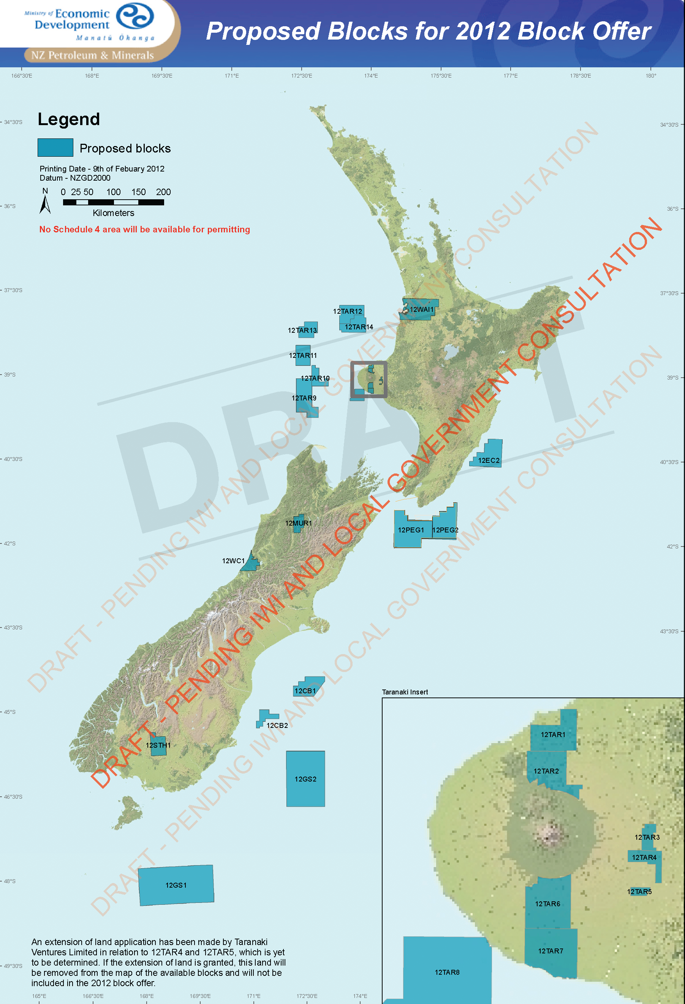
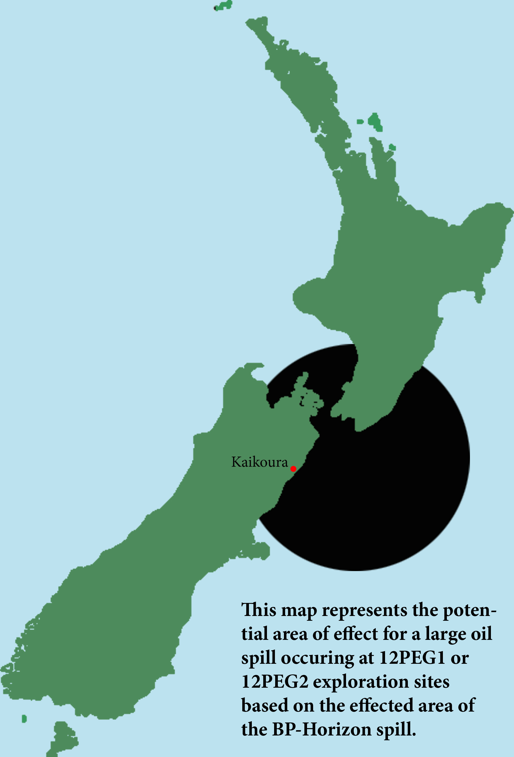
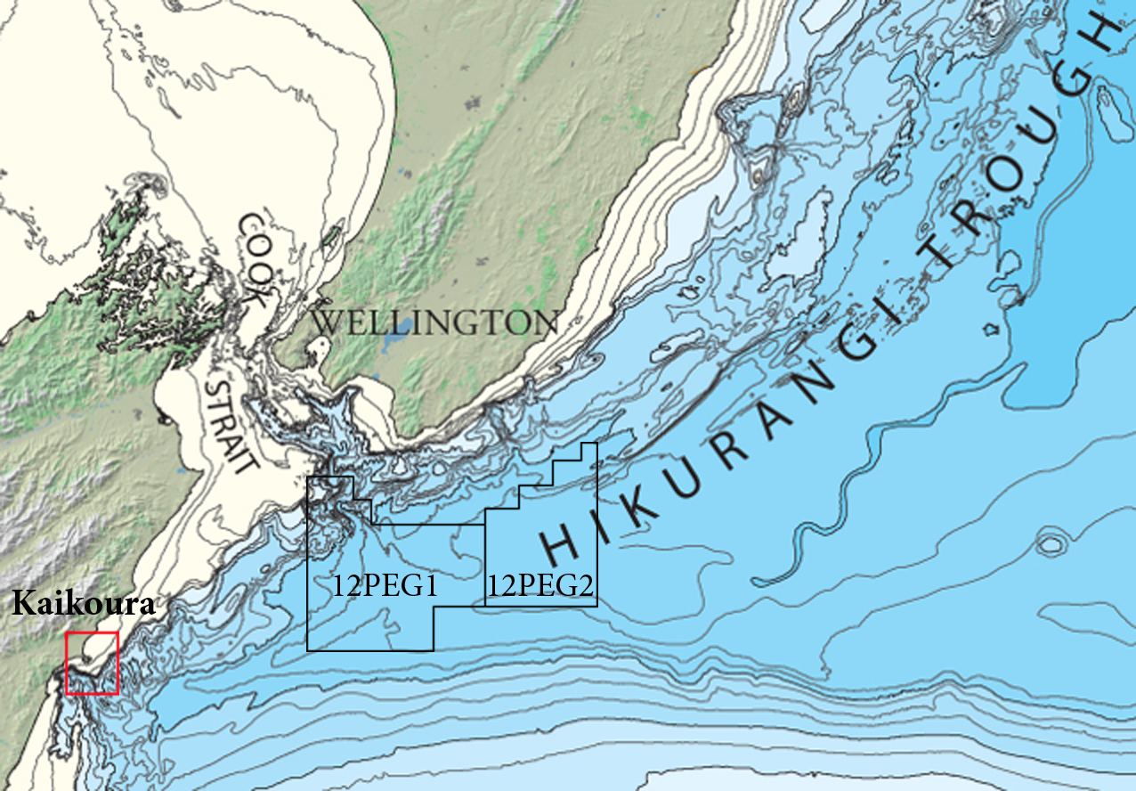

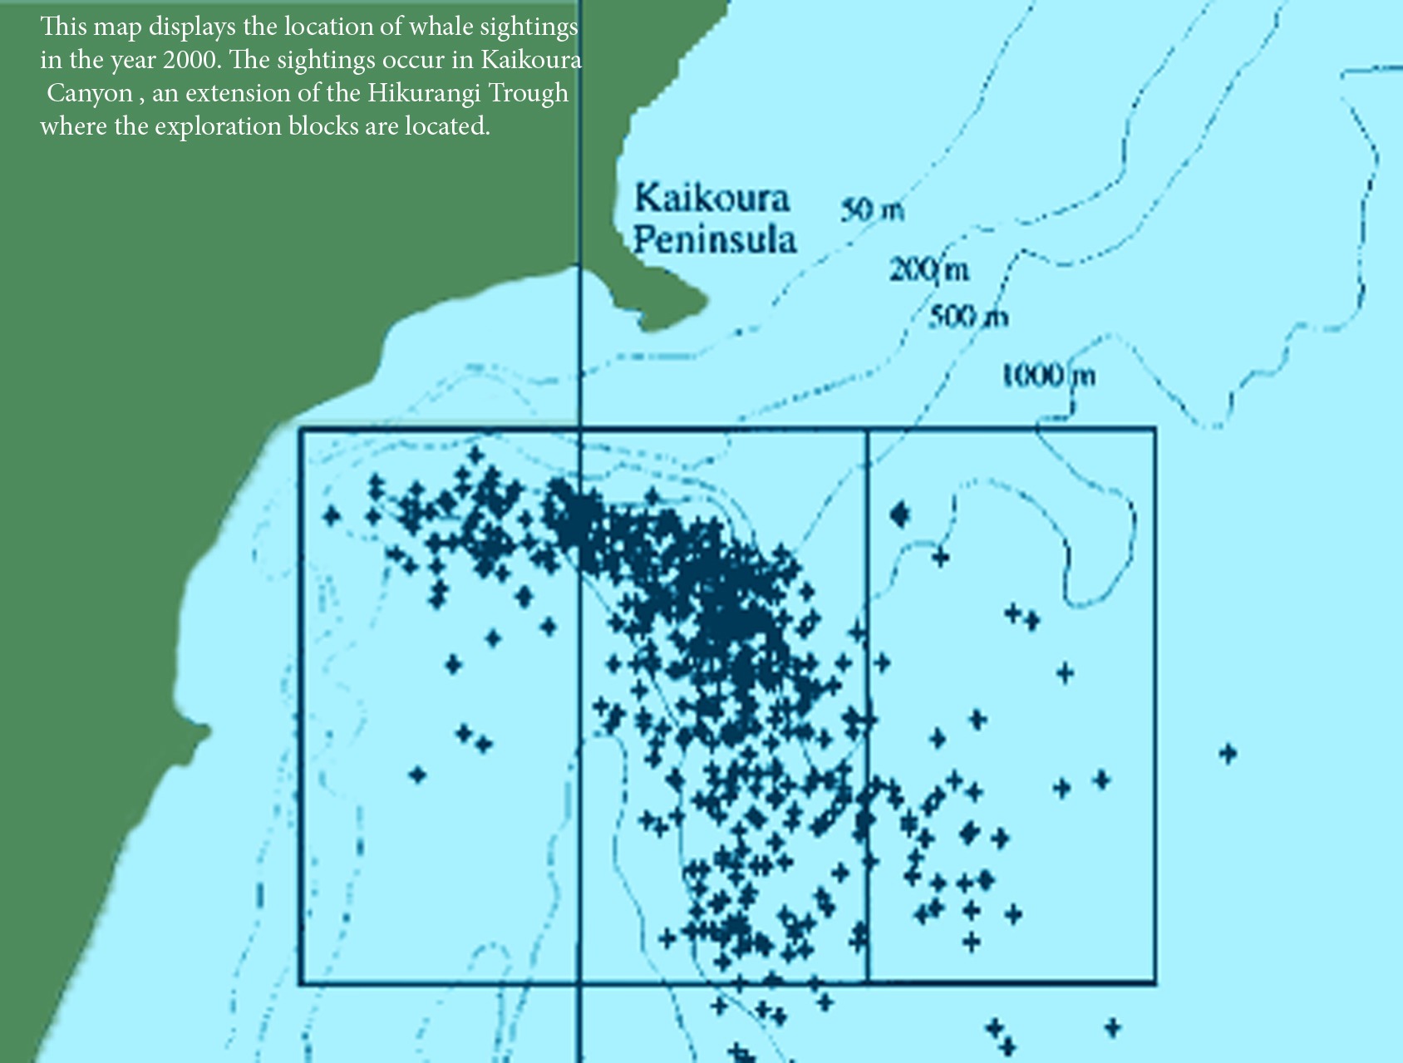

Costs & Benefits of Proposed Oil Drilling Near Kaikoura Canyon
(Blocks 12PEG1 & 12PEG2)

Benefits
Increase in oil and gas production and exports

Allow New Zealand to select and limit locations for exploration

Increase New Zealand’s Gross Domestic Product

Increase New Zealand’s international political power and self-reliance

Create thousands of job opportunities

Costs
Significantly damage New Zealand’s “green” reputation

Endanger the ecotourism industry

High risk of oil spills due to the location of suggested drill sites

Contribute to global climate change through burning of extracted fossil fuels

Release harmful pollutants into the water

Negative impact on whales due to anthropogenic noise

Threaten at least eighteen marine mammal species in the area

Jeopardize local economies

Engage New Zealand in unstable boom-and-bust econo

According to New Zealand Petroleum and Minerals, a branch of the Ministry of Economic Development, oil and gas production currently contributes about 2.5 billion dollars to the national GDP. The new block system proposed by the New Zealand government allows the government to select areas identified as having oil and gas potential to offer for bidding. Companies will no longer be able to apply for permits outside of the block offer process, which is beneficial because in the past companies could apply to explore any area at any time, with only a five day window for competitive interest (2012 Block Offer Q&A). By entering into the international oil market, New Zealand will become more self-reliant and have more political power to wield.
However, if New Zealand is established in the international oil market, it will severely damage their international reputation as an environmentally friendly country. In a poll taken of UK tourists visiting Australia, ninety-seven percent of tourists said they went to Australia for the wildlife, and the beauty of the beaches; similar numbers would be expected for those traveling to New Zealand. The presence of oil drills off the coasts of New Zealand would have a very strong negative impact on the ecotourism industry in New Zealand. The depth the proposed site of drilling, an underwater canyon plunging to over twenty five hundred meters deep, is nearly twice as deep as the BP drill site in the Gulf of Mexico. It is also precariously located in earthquake prone areas, making it a high-risk location for complications like oil spills.
Oil exploration in the area near the Kaikoura Canyon will threaten at least eighteen unique marine mammal species, including three endangered species, the blue whale, Hector’s dolphin, and the fin whale. Many communities, including Kaikoura, are centered on ecotourism, and if the incredible sperm whale and playful dusky dolphins no longer call this area home, the local economy will be destroyed. This is especially disastrous because these communities are currently quite sustainable. As long as the animals are not disturbed, they will continue to thrive. In contrast, oil drilling leads to boom-and-bust economies, involving a strong boost in economy for a limited period, followed by a steep decline when the oil is depleted. Furthermore, the drilling will threaten the long-term success of ecotourism in the affected areas.
Taking into account the entirety of the nation and its people, the monetary gains of the proposed oil drilling will be drastically outweighed by the risks and environmental degradations it entails.

Legal & Justice Issues

Upon reviewing the upcoming proposal by New Zealand Petroleum and Minerals to offer on and off-shore blocks of the New Zealand coastline for oil and gas exploration, drilling, and hydraulic fracturing I feel highly compelled to voice a question as to the validity of this proposal in absence of consultation or assessment by all groups potentially affected. According to a letter sent to Garry Daniell of Masterton District Council by the General Manager of NZ Petroleum and Minerals, an intention for the block offer approach to offshore drilling is to be “more transparent for local communities, industry and iwi”. Despite this, many crucial local parties, including the Kaikoura District Council and Te Korowai o Te Tai o Marokura, were never consulted. Te Korowai, along with the Department of Conservation, assembled six years ago and have been working ever since, on a plan to most appropriately conserve Kaikoura’s coastline. In their efforts they have become an example in seeking the good of a community as a whole, from not only economic, but social and environmental perspectives. The fact that groups like these have not received a consultation offer about this proposal is outrageous and represents at minimum an act of grave irresponsibility and neglect on the part of the requesting party. Unfortunately, scrutiny of this case seems to indicate that the exclusion of Kaikoura groups from influencing the proposal was done arbitrarily in light of the massive opposition by these groups to offshore oil exploration.
Under the Resource Management Act of 1991, district councils only have the power and jurisdiction to establish the required degree of consultation if the intended site for exploration and development in within twelve miles of the local coast. Unfortunately, this reflects a massive misrepresentation of the potential impact zone of an oil spill or earthquake. Considering the history of this form of resource extracting internationally, these side effects and potential accidents should be considered a high risk for surrounding areas. The 12PEG1 and 12PEG2 blocks come as close as 75 kilometers from the Kaikoura peninsula. They are along the migratory route and major feeding ground of many precious marine mammals and organisms. Based on the marine ecology, seismology, and extent of marine currents in the ocean region surrounding the 12PEG1 and 12PEG2 blocks, the radius of impact would greatly exceed twelve miles. In fact, it would well exceed the 75 kilometers to Kaikoura’s coastline. The recent oil spill in the Gulf of Mexico covered an area the size of the entire south island. Certainly a spill, earthquake or tsunami originating less than 100 km away would do considerable ecological damage to the otherwise thriving habitat of Kaikoura’s coast. In addition, the interruption of marine mammal migratory paths and sonar communication by loud, dangerous machinery could have devastating effects on the marine mammal populations that sustain Kaikoura’s ecotourism-based economy.
It’s clear that an ethical and reasonable course of action would be to take the interests of the Kaikoura District and others similarly affected into consideration when their community is asked to shoulder the potential consequences of this proposal. Yet, despite diligent expressions of protest the from multiple Kaikoura interest groups and a petition with over 2,300 signatures, (including over 800 local signatures out of a total 1250 households), the Ministry of Economic Development has been disturbingly dismissive. On the 5 April meeting of parliament, during a questioning by MP Gareth Hughes, Phil Heatley, the Minister of Energy and Resources refused a response to the question of whether his office had taken into consideration a letter from the Mayor of Kaikoura detailing concerns with the depth of drilling, inability to contain spills, fault lines that go through the block, and location of protected species. When it was brought to the attention of the proceeding that the only correspondence that the Kaikoura District Council received was a brief tele-conference, Hughes felt he couldn’t comment on the sufficiency of this correspondence, as he was not a part of this conference. This neglect is an insult to the values that must sustain the policies of the New Zealand government. Serving the local life-blood economies of towns like Kaikoura and the constituents who dwell in them should be of the utmost priority in economic development, and preservation of natural resources like the marine life of Kaikoura canyon ought to be central to discussions of resource management.
New Zealand Petroleum and Minerals would assert that their desire to sell plots to overseas oil companies is intended to ultimately benefit the New Zealand populace. As this has shown to clearly not be the case, a transparency of the politics that have led to this proposal must be called for. To further overlook the concerns of towns like Kaikoura who have an interest in protecting their otherwise sustainable resources and community economy is unacceptable. Therefore, I propose a reassessment of the proposed blocks with a legitimate risk assessment and consultation by all parties potentially affected and a fully open provision of intent with supporting legislation, within a reasonable window of time for critique and response. I propose this to ensure the commitment of the New Zealand government to ecologically responsible resource management, community sustainability, and representation of the public.

-Amanda Siegel

Video of MP Gareth Hughes questioning Minister Phil Heatley in Parliament
http://www.youtube.com/watch?v=caJDa-B2MuY

Painting the Ocean Red: A Response to Kaikoura Oil Exploration
Tamara Lang

Mere decades ago, you could not walk around the peninsula of Kaikoura, New
Zealand without wading through the blood of whales. Your feet would have been stained
by the lifeblood that had once passed through a heart larger than yourself, but which
now dyed the rocks and tide pools a mocking red.

Why were these giants of the sea reduced to pulp? The answer is the same as
that word which today reverberates throughout Kaikoura: oil.

At this very moment, the New Zealand government seeks to begin drilling for oil
off of the Kaikoura coast. Against the vehement protests of the community, New
Zealand Petroleum and Minerals is preparing two blocks of ocean ﬂoor near Kaikoura to
be put up for auction. From these sites, pipelines will reach down to pierce the rocky
bottom, pumping tons upon tons of oil from the waterʼs dark depths.

These derricks will not merely be passive blots on the landscape, but will present
a very real danger to the marine ecosystem. Even in the best scenario, without a spill,
the process of oil drilling releases dangerous chemicals into the substrate; these
chemicals will eventually emerge into the water column. By-products of toxic sludge are
a certainty. The process of extracting resources from the ocean will also introduce
substantial noise pollution, a situation which may prove disastrous in waters so deep
that whales and dolphins can see only with sound.

These are the certain side effects. Yet the development of these oil rigs presents
an even graver danger in the form of a gamble with the earth. The area around
Kaikoura is a region carved with fault lines, messages of earthquakes both past and
future. New Zealand is a place very familiar with the tremors of the earth; here, the
danger of earthquakes is a story as old as the mountains.

The oil blocks will be developed along the Hikurangi trough, a 1.5-mile-deep
chasm torn in the ocean ﬂoor where the Australian and Paciﬁc plates collide. The
landscape, both below and above sea, is stunning; along the coast the Seaward
Kaikoura mountains stretch in snowy splendor, while beneath blue waves the valley of
the Hikurangi trough weaves in unseen grace. Kaikoura, like the rest of New Zealand, is
suspended along the arc of seismic fury known as “the Ring of Fire,” a tectonic hotspot
which curves around the Paciﬁc ocean through Hawaii, Alaska, and Japan. In New
Zealand, the fervency of the resulting earthquakes and volcanoes is carved into the very
hills. It is this volatile nature of the earth that has given the region its wildness;
Kaikouraʼs stunning landscape is that of grandeur shaped by force.

The beauty that has resulted is incomparable. The regionʼs jewel is the Kaikoura
canyon, a 4,900 foot deep undersea chasm that fosters a vibrant array of deep-sea life.
This canyon serves as the food basket for a host of marine mammals, including 14
species of whales and dolphins that thrive in the rich productivity of these waters.
Kaikoura boasts a diversity of marine life that is unique on the planet; fur seals, sperm
whales, dusky dolphins, and albatrosses can all be seen in the space of a single
morning.

The greatest allure of Kaikoura canyon, though, is the whales. The rich water of
the canyon creates a nursery of sorts, where male sperm whales spend the decades of
their youth. Kaikoura has gained international recognition as a whale-watching
destination, a reputation that has spurred the economy of this former ﬁshing village, as
well as bringing this Southern California student to learn from the waters.

Watching the Kaikoura whales is a surreal experience, not so much for what is
seen but for what is left unseen. Once the sperm whale disappears from the waterʼs
surface, he drops headﬁrst into the oceanʼs most secret places. The light around him
dissolves until nothing but blackness remains. Mountains arc beneath dustings of
marine snow, while great sharks wind through valleys that no foot will ever touch. Here,
the stars are made of blue-lit invertebrates and the rivers are formed from schools of
silver ﬁsh. Almost a mile below the hull of our boat, thereʼs another world whose secrets
the sperm whale will never tell.

Itʼs humbling to imagine such a beautiful world cycling on beyond the reach of
human eyes. Each of the creatures beside which the Sperm Whale swims is a marvel of
biotic intricacy, yet they live suspended in darkness so thick that only the Creatorʼs eyes
can penetrate. This Creation resounds with the memory that it was created good. It
serves as a testament that all of Creation, not only that which we can use, was
fashioned with the care and compassion of the God who “so loved the World” (John
3:16).

The result is a riotous hymn to the glory of God. From the canyonʼs deepest
wrinkle to the wind upon the waves, the ocean around Kaikoura is churning with lives
that shout praise to their Creator. The dusky dolphinsʼ triumphant play, the albatrossesʼ
journeys that press on through time and space and sight and smell, the crackle of krill
and the twirl of seals all join in a never ending testimony that their Creator is good and
He has made them thus. Even the sperm whales live this truth; by doing all that they
were created to do, they bring glory to their Maker.

Sadly, we humans sometimes forget to do the same. At the beginning of history
we were given a job: Genesis 2:15 tells us that “The Lord God took the man and put him
in the garden of Eden to tend and keep it” (Gen 2:15, NJKV). This verse is important for
several reasons. First, it tells us what we are meant to be doing. Humans werenʼt meant
simply to take from the land, but were created to serve the earth. We were meant to
“keep” the garden, to protect it from harm.

Just as important is what this verse tells us about ourselves. The word translated
“man” is the Hebrew word “adam,” which is both a name and an inclusive term for
humanity. The word derives from the Hebrew word “adamah,” which means “earth” or
“soil.” Thus, in the very name of humanity there is the constant reminder that we were
made of the same soil which now we till. Humans were not created as something
severed from the rest of Creation, but were made as a part of the earth; tellingly, the
Creation narrative places humanityʼs creation on the same day as that of other land-
dwelling animals.

However, as humans we have been given special responsibilities. Genesis 1:26
reads, “Then God said, “Let Us make man in Our image, according to Our likeness; let
them have dominion over the ﬁsh of the sea, over the birds of the air, and over the
cattle, over all the earth and over every creeping thing that creeps on the earth” (Gen
1:26, NKJV). In these verses, we are given the task of representing God as mini-rulers
over Creation, a position similar to that of the governors or representatives that ancient
rulers would place as “images” throughout their realms.

Yet, though we are called to dominion, we are not permitted to dominate.
Throughout the Old Testament, the qualities of a good ruler arise as a vital motif. Psalm
72 provides an example of such a text; here the ideal King is describes as one who
brings justice to the disadvantaged, freedom to the oppressed, peace to those stricken
by violence. This King fosters fruitfulness and abundance among his people. The good
King is a servant and not a dictator, a helper and not a destroyer.

This, then, is the model that we must use when we seek to enact our role as
Godʼs image-bearers. It is easy to locate those creatures that are disadvantaged,
oppressed, or victims of violence. Such a memory still echoes amid the once-bloody
whaling ﬂats of Kaikoura. We must not let such wrongs go unstopped. If we are to fulﬁll
the job for which we were created, then we must work to protect these creatures that
God has created alongside us. We cannot glorify God while we destroy His Creation
and neglect His commandments. To do so goes not only against our laws, our tastes, or
our culture; it goes against the very core of the creatures we were made to be.

Sadly, we are often the bringers, not of protection, but of destruction. I can
remember when our own Gulf Coast hosted an abundance of marine life similar to that
of Kaikoura. Many coastal towns, like Kaikoura, were hot-spots for ﬁshing and tourism.
Entire communities thrived on the richness of their ocean.

Then, in the space of a single moment, on a single oil derrick, a single accident
obliterated this richness of life. The blackness that scarred the oceanʼs skin covered the
same area as New Zealandʼs entire South Island.

Weʼve all seen pictures of marine animals after oil spills -- feathers pleated with
oozing gunk, corpses of seals pushed through black waves onto a black beach. Imagine
a royal albatross suffering this foul fate. Imagine a sperm whale surfacing in a sea as
dark as his own skin.

If oil drilling is allowed in Kaikoura, it is only a matter of time before this horror
becomes a reality. 4,900 feet of pipeline, reaching from a volatile bottom to a wild
surface, will be strung in a region of precarious seismic stability. Think of Japanʼs
nuclear meltdown following an unforeseen quake. By placing oil drills in the canyon, we
are condemning Kaikouraʼs marine life to a similar fate.

Perhaps it may be a decade, a century, a few centuries before a quake hits
Kaikoura and releases the dark ﬂood. However, by placing this equipment in the ground,
we are creating a time bomb that we know little about. It may be that our great-great
grandchildren will have to see the destruction of the Kaikoura canyon, or perhaps we
ourselves will be forced to deal with our own foolishness.

In the past we have dyed the rocks red with our greed; let us not now paint them
black with our folly. We owe it to the rocks. We owe it to the whales. As we are a part of
this world, we owe it to ourselves.

And, ultimately, we owe it to our God.
.

Conclusion
The oil companies that end up off the coast of New Zealand might manage to have clean, safe practices, which in theory will not destroy or disrupt too much of the nearby environment. And then again, as often heard, the gap between practice and theory might prove quite a bit larger in practice than in theory.
Two years out, the big businesses might scoff with parliament at the “alarmists” when no catastrophe has yet come. But six years out when the ecosystem reveals the effects of slow addition of toxins and eight years out when the next earthquake strikes, the short-term profit could be correctly identified as unwise.
Here in Kaikoura, if not yet all around New Zealand, there is great concern about offshore oil exploration and drilling. We the students of the Creation Care Study Program offers these materials to make known the situation, with the hope that informed action can still change something.

Bibliography

Christian Views
Bouma-Prediger, Steven. “For the Beauty of the Earth.” Baker Academic 2001, 2010
DeWitt, Calvin B. “Earthwise.” Faith Alive Christian Resource 2001,2005, 2011
Ray, John. ”A persuasive to a Holy Life: from the Happiness Which Attends it Both in This World, and in the World to Come.” Grand Rapids, MI: Christian Classics Ethereal Library 1719.
Ecotourism
Constantine, Rochelle. “Effects of Tourism on Marine Mammals in New Zealand.” Science for Conservation: 106 1999. 6 April 2012.
Dangerfield, Emma. “Fracking no good for ecotourism.” The Kaikoura Star http://www.stuff.co.nz/marlborough-express/news/kaikoura/6420034/Fracking-no-good-for-eco-tourism 6 April 2012.
Hoyt, Erich. “Sustainable Ecotourism on Atlantic Islands, with Special Reference to Whale Watching, Marine Protected Areas and Sanctuaries for Cetacean.” Biology and Environment: Proceedings of the Royal Irish Academy, Vol. 105B, No. 3, Fauna and Flora of Atlantic Islands November 2005: pp141-154.
Tourism Queensland. “The UK Ecotourism Market.” 6 April 2012.
Environmental Impacts
Barre, Alassane et all. “What’s Shaking Arkansas Does the natural gas drilling in central Arkansas contribute to earthquakes?” 6 April 2012.
Brodie, J. W. “Coastal surface currents around New Zealand.” New Zealand Journal of Geology and Geophysics, 3:2 9 Jan 2012. 6 April 2012. P 235-253.
Dubois, Jennifer. “The Plausibility of a Submarine Landslide Generated Tsunami at Kaikoura Canyon.” 2011
Ellsworth, W. L. et all. “Are Seismicity Rate Changes in the Midcontinental Natural or Manmade?” SSN Seeion: the M5.8 Central Virginia and the M5.6 Oklahoma Earthquakes of 2011 April, 18 2011. 6 April 2012.
Ministry of Economic Development Manatu Ohanga. Carbon Capture and storage. 2012. 6 April 2012.
Ministry of Economic Development Manatu Ohanga. How Carbon could be catured and stored. 2012. 6 April 2012.
Nicoll, Jared. ”Seismic tests given the go-ahead.” Marlborough Express http://www.stuff.co.nz/marlborough-express/news/kaikoura/6194457/Seismic-tests-given-the-go-ahead 6 April 2012.
Fracking
Dangerfield, Emma. “No moratorium on govt agenda.” Marlborough Express http://www.stuff.co.nz/marlborough-express/news/kaikoura/6613317/no-moratorium-on-govt-agenda 6 April 2012.
Manuel, John. “EPA Tackles Fracking.” Environmental Health Perspectives, Vol. 118, No. 5 May 2010 p. A199.
Ministry of Economic Development Manatu Ohanga. ”Frequently asked question about fracking.” NZ Petroleum and Minerals 2012.
Morton, Sam; Fairfax. “Fracking probe hailed as timely.” Marlborough Express http://www.Stuff.co.nz/Marlborough-express/news/6656845/fracking-probe-hailed-as-timely 6 April 2012.
Legal / Government
Craig, John et all. “Conservation Issues in New Zealand.” Annual Reviews Ecological Systems 2000 31:61-78. 6 April 2012.
Dangerfield, Emma. “Oil protest petition gathers support.” The Kaikoura Star http://www.stuff.co.nz/marlborough-express/news/6624346/Oil-protest-petition-gathers-support 6 April 1012.
Dangerfield, Emma. “’No drill’ protest on Sunday.” The Kaikoura Star. http://www.stuff.co.nz/marlborough-express/news/6624346/Oil-protest-petition-gathers-support 6 April 2012.
Dangerfield, Emma. “Kaikoura takes fracking action.” The Kaikoura Star. http://www.stuff.co.nz/marlborough-express/news/kaikoura/6543275/Kaikoura-takes-fracking-action 6 April 2012.
Environmental effects bill: http://www.legislation.govt.nz/bill/government/2011/0321/latest/DLM3955428.html 6 April 2012.
Her Excellency the Governor General. “Minerals Programme for Petroleum.” Department of State: Crown Minerals 6 December 2004. 6 April 2012.
Knight, Kim. “Troubled waters over oil.” The New Zealand Herald http://www.stuff.co.nz/national/5069775/Troubled-waters-over-oil 6 April 2012
Ministry of Economic Development Manatu Ohanga. ”Block Offers.” NZ Petroleum and Minerals 2012.
Ministry of Economic Development Manatu Ohanga. Petroleum Action Plan. 2012. 6 April 2012.
Ministry of Economic Development Manatu Ohanga. Oil and Gas. 2012. 6 April 2012.
Ministry of Economic Development Manatu Ohanga. ”What are the different types of permits?” NZ Petroleum and Minerals 2012.
Ministry of Economic Development Manatu Ohanga. Proposed changes to the petroleum regime. 2012. 6 April 2012.
Ministry of Economic Development Manatu Ohanga. “Questions and Answers.” http://www.med.govt.nz/sectors-industries/natural-resources/pdf-docs-library/oil-and-gas/crown-minerals-act-review/CMA%20Review%20-%20QA%20-%20Mar%2012%20FINAL.pdf 6 April 2012.
Ministry of Economic Development Manatu Ohanga. “Making a Submission.” http://www.med.govt.nz/sectors-industries/natural-resources/pdf-docs-library/oil-and-gas/crown-minerals-act-review/ 6 April 2012.
Ministry of Economic Development Manatu Ohanga. “2012 Block Offer Invitation for Bids.” New Zealand Government. 2012
Reid, Neil. “Oil strike could be worth $600m.” The New Zealand Herald http://www.stuff.co.nz/national/6481094/Oil-strike-could-be-worth-600m 6 April 2012.
St. Clair, Mark et all. ”Providing National Guidance on Infrastructure through the RMA” Ministry of Economic Development and Ministry for the Environment September 2010.
Marine Life
Baxter, Andrew S. “The Management of Whale and Dolphin Watching Kaikoura, New Zealand.” Department of Conservation 6 April 2012.
Carter, Dr. Lionel; Duncan, Miles; Mitchell, John. “Benthic Habitats Of Kaikoura-Physical characteristics from side-scan sonar and depth imagery.” NIWA Client Report; National Institute of Water and Atmospheric Research Ltd July 2004.
Cummings, Jim. “Does Moderate Anthropogenic Noise Disrupt Foraging Activity in Whales and Dolphins?” http://www.AEInews.org 6 April 2012.
Jaquet, Nathalie; Dawson, Stephen; Slooten, Elisabeth. “Seasonal distribution and diving behavior of male sperm whales off Kaikoura: foraging implications.” Canada J. Zoology Vol. 78 2000.
Marsden, Assoc. Prof. Islay D. “Kaikoura Coast Literature Review.” Estuarine Research Report 32 August 2007. 6 April 2012.
Rattenbury, M.S., Townsend, D.B.,Johnston, M.R. (compilers) “Geology of the Kaikoura Area.” Institute of Geological and Nuclear Sciences Limited 2006.
Watwood et al. “Deep-Diving Foraging Behaviour of Sperm Whales (Physeter macrocephalus).” Journal of Animal Ecology, Vol. 75, No. 3; British Ecological Society May, 2006.

